Multiple choice section

Question 1 [7.3]

The opposite operation to ÷ 4 is:

A + 4 B – 4 C × 4 D ÷ -4

Question 2 [7.3]

The expression missing from the box below is:

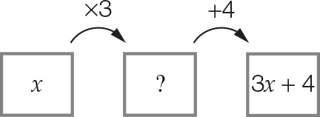

A x + 3 B 3x C x + 4 D 4x

Question 3 [7.1]

The number missing from the equation 3 × 8 = __ + 6 is:

A 30 B 4 C 24 D 18

Question 4 [7.2]

Two times a number plus four is equal to ten is the same as:

A 2n + 4 = 10 B 2 + n + 4 = 10 C n + 4 = 10 D 2n – 4 = 10

Question 5 [7.5]

A pizza with eight slices was shared among four people. Each person ate half of their share. How many slices were left altogether?

A 2 B 4 C 6 D 12

Question 6 [7.2]

A number divided by four is equal to fifteen plus five. The number is:

A 100 B 5 C 80 D 16

Question 7 [7.3]

Using backtracking, the first step to solve  = 6 is to:

A multiply both sides by 2 B subtract 5 from both sides

C multiply both sides by 5 D subtract 6 from both sides

Question 8 [7.4]

 is equivalent to:

A  B  C  D 

Question 9 [7.4]

To balance the equation, the expression  must equal:

A 2 B 4 C 10 D 18

Question 10 [7.2]

Which equation describes ‘the time (t) taken plus 20 minutes equals 75 minutes’?

A 20t = 75 B t + 20 = 75 C 20 – t = 75 D 75 + 20 = t

Multiple-choice total marks: ____ / 10

Short answer section

Question 11 3 marks [7.3, 7.4]

variable unknown inverse solution equivalent

(a) When backtracking, we undo an operation by using the _______________ operation.

(b) To solve an equation is to find the value of the ____________________.

(c)  and  are _______________ equations.

Question 12 2 marks [7.3]

Describe the process of checking by substitution. Use an example to help you explain.

Question 13 3 marks [7.1]

State true (T) or false (F) for each number sentence.

(a) 4 + 5 × 2 = 18 (b) 29 – 8 = 4 + 24 (c) 10 × 4 = 

Question 14 2 marks [7.1]

Write the following as a number sentence using numbers and mathematical symbols only.

(a) Seventy-five added to six is equal to eighty-one.

(b) Fifteen divided by three is equal to twenty divided by four.

Question 15 1 mark [7.1]

Teo is 15 cm taller than Juan. If Juan is 142 cm tall, write a number sentence to show Teo’s height.

Question 16 3 marks [7.2]

Write each of the following equations in words.

(a) y + 8 = 12

(b) 

(c) 

Question 17 2 marks [7.2]

For the following equations, check whether the value given in the brackets is the correct solution.

(a) b + 9 = 12 (b = 3) Yes or No

(b)  (x = 84) Yes or No

Question 18 2 marks [7.3]

The following flowchart represents an equation.

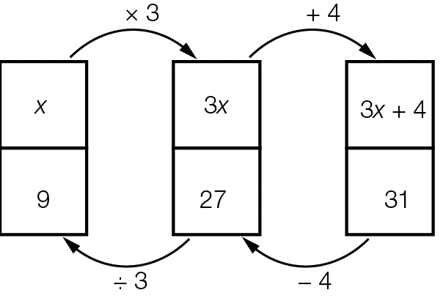

(a) What is the equation to be solved?

(b) What is the solution to the equation?

Question 19 2 marks [7.3]

Draw a flowchart and use backtracking to solve the equation .

Question 20 4 marks [7.4]

Solve each of the following equations.

(a) 

(b) 

Question 21 2 marks [7.3]

A number is tripled then two added to the result to give an answer of seventeen. Write an equation and then solve using backtracking. Use n to represent the unknown number.

Question 22 2 marks [7.4]

The set of scales is balanced. The left-hand side has 7 apples and the right-hand side has 1 pineapple and 2 apples.

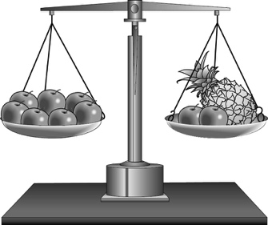

(a) If two apples are taken from the left-hand side, the scales become unbalanced. Which side is now heavier?

(b) How can the scales be balanced without putting the apples back onto the scales?

Question 23 6 marks [7.4]

Form an equivalent equation to each of the following by performing the operation given in brackets to both sides of the equation. Check that each pair of equivalent equations has the same solution.

(a) x + 9 = 12 (+ 6)

(b) x – 11 = 14 (+ 4)

(c) x – 7 = 3 (– 9)

Question 24 4 marks [7.4]

Solve each of the following equations using the balance method.

(a) 6x + 2 = 26 (b) 

Question 25 3 marks [7.5]

The perimeter of a rectangle is 56 cm. If its length is three times its width, find the dimensions of the rectangle.

Question 26 3 marks [7.5]

Jeremy has $250 to spend on two pairs of jeans. After buying them, he had $58 left over. Each pair of jeans cost the same amount.

(a) Write an equation that shows this situation.

(b) How much did each pair of jeans cost?

Short answer total:_________/44

Extended answer section

Question 27 4 marks [7.5]

The following dominoes need to be placed on the board so that the ends of each joining dominoes have the same value. Which two dominoes can be used to form a square so that the puzzle is complete?  
Hint: Find the values of a.

|  |  |  |  |  |  |  |  |
| --- | --- | --- | --- | --- | --- | --- | --- |
| Domino 1 | |  | Domino 2 | |  | Domino 3 | |
| 4a + 6 = 22 | a – 3 = 4 |  | a + 6 = 10 | a – 13 = 7 |  |  | 3a + 4 = 37 |
| Domino 4 | |  | Domino 5 | |  | Domino 6 | |
| 2a + 1 = 15 |  |  |  | a + 8 = 20 |  | 4(a + 1) = 32 | a + 15 = 17 |

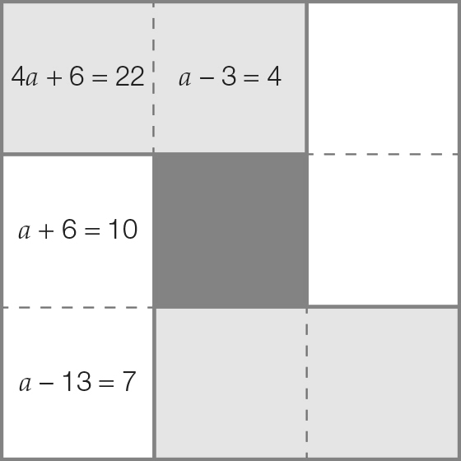

Question 28 6 marks [7.5]

In number pyramids, the square on top of the middle of two others contains their sum.

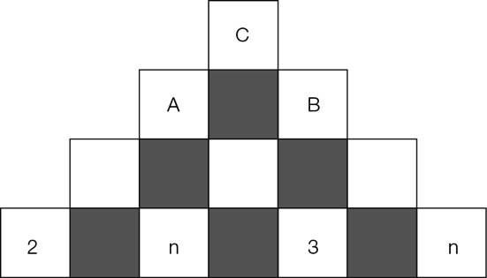

(a) Use the letter n to write expressions for the sums at positions A, B and C in the pyramid. (Write your answers in simplest form.)

A: ____________________________________________________ = _______________

B: ____________________________________________________ = ________________

C: ____________________________________________________ =________________

(b) You are told that the top number is 27. Write an equation using n.

(c) Solve the equation from (b) for n. Check your answer in the pyramid.

Extended answer total:_________/10

TOTAL test marks: _______ / 64